**CHAPTER 1**

1. **Introduction**
   1. **About the Company:**

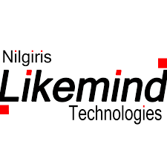

Fig 1.1: Logo of Likemind Technologies

Likemind Technologies was inspired and incepted by a bunch of IT professionals with a common background of having lived in Ooty and worked together at a certain point of there career. Likemind Technologies in Ooty is one of the top Computer Software Developers in Ooty.

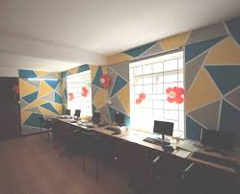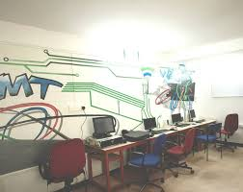

Fig 1.2: The Company

They are a bunch of experienced IT professionals from Ooty who chose to stay back in nature's lap and provide cutting edge software and services to the far corners of the world. They have clients in India, UK and the remote nation of Mongolia. Their main strength is their ability to quickly turn around with an open source solution in the following areas: - ERP, CRM, Content Management, School and Hotel Management.

[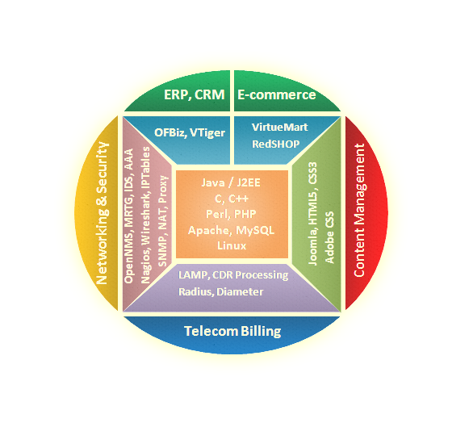](http://likemindtech.com/images/pro_bg.png)

Fig: 1.3 The Areas They Work On.

The team of technical staff are well versed in ERP/CRM Content Management, Telecom Billing, Network Management

They are an experienced team who provides solutions based on opensource technologies for more than a decade. They work on few solutions like

* Auction Management System
* Content Management System
* Design and development of modules for Telecom Billing
* Design and development of modules for Network Management

Customized CRM and ERP solutions for schools, hotels and factories.

They work on php developments like:

* Custom Application Development
* E-Commerce Solution
* CMS
* Web Portal Development
* PHP Open Source

The complete BlueBill system has been designed and developed by Likemind Technologies with ease of customization in mind. The following are some of the custom features: Company logo, address, colour scheme. Layout of data entry forms and reports Wage slabs, tax slabs, allowance, incentives, etc. New modules can be developed based on requirement.

**1.2 ABOUT THE INTERNSHIP**

On 2 May 2018 I started my internship at Likemind Technology. I was trained on basic command of Linux and Web Development.

Moving from college to In-plan training have trained me in knowledge and have practical exposure to get a clear idea about how companies work and what type of works will be handled in company and industry from documentation to project stage. This In-plan training has given me a basic knowledge and confidence how to face interviews.

Practical exposure on programming languages and having interaction with real-time working with few theoretical knowledges has helped me think practically. This In-plan training has taught me how to be a leader and a smart worker.

By completing this In-plan training company has trained and certified me with a completion of the training.